**D**

Click Triggers, then click +New:

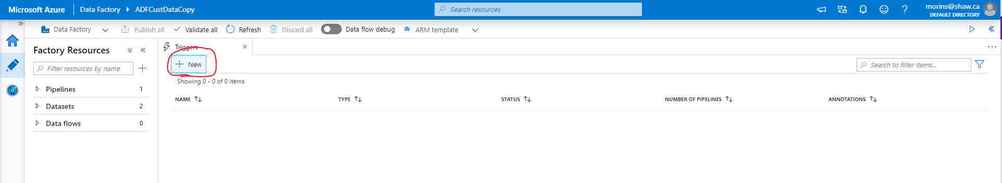

Fill in the details of the New Trigger, select the type (Schedule, Tumbling Window, Event):

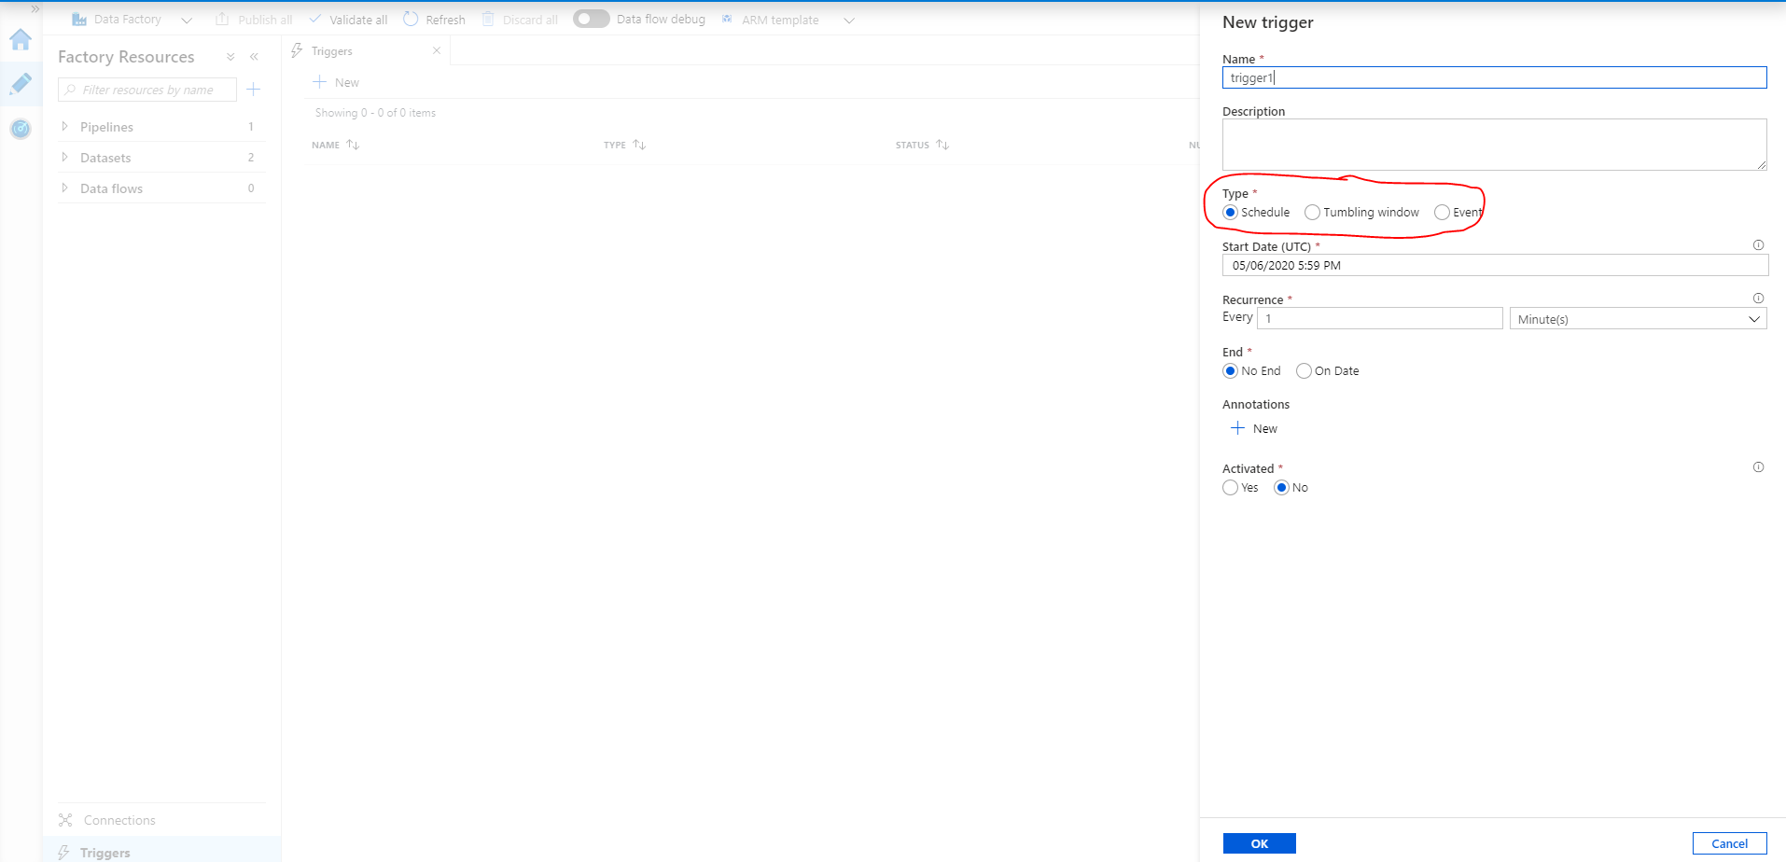

**Schedule Triggers**

Schedule triggers can execute one or more pipelines on a set schedule. You have full control and flexibility of the day(s) and time(s) you want to run the trigger, and you can define a start and end date for when the trigger should be active.

You can define a basic recurring schedule, such as:

* Every 2 hours
* Every Sunday at 16:00 UTC and 22:00 UTC

You can also define an advanced calendar schedule, such as:

* Every 15th day and last day of the month at 18:00 UTC
* Every first and third Monday of the month at 04:00 UTC

Important note is that all times are in UTC.

Schedule triggers and pipelines have a many-to-many relationship. That means that one schedule trigger can execute many pipelines, and one pipeline can be executed by many schedule triggers.

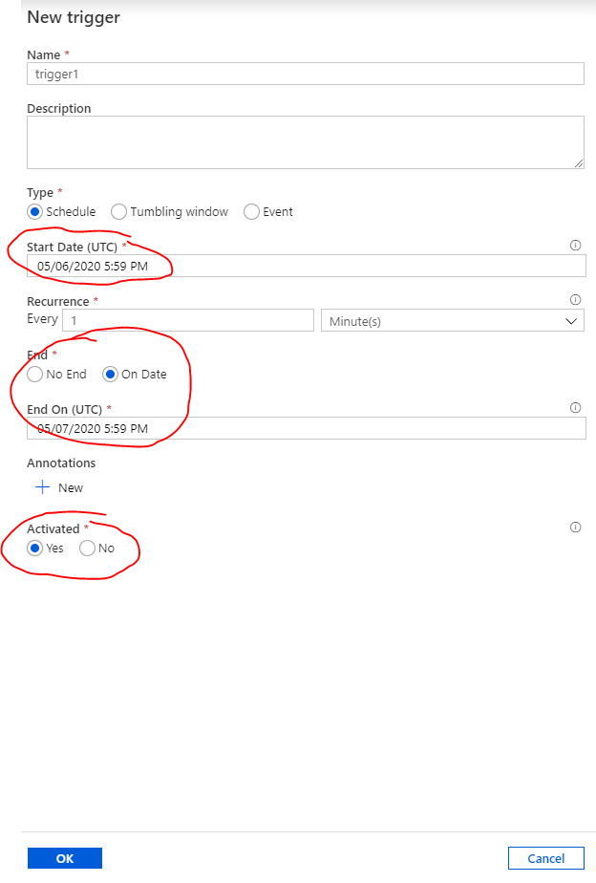

Depending on the recurrence method, you will get different advanced settings:

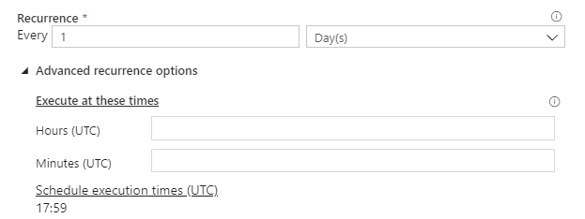

**Tumbling Window Triggers:**

Tumbling window triggers can execute a single pipeline for each specified time slice or time window. You use them when you need to work with time-based data, do something with each slice of data, and each time slice or time window is the same size.

A common use case is when you want to copy data from a database into a data lake, and store data in separate files or folders for each hour or for each day. In that case, you define a tumbling window trigger for every 1 hour or for every 24 hours. The tumbling window trigger can pass the start and end time for each time window into the database query, which then returns all data between that start and end time. Finally, the data is saved in separate files or folders for each hour or each day.

The cool thing about this is that Azure Data Factory takes care of all the heavy lifting! All you have to do is specify the start time (and optionally the end time) of the trigger, the interval of the time windows, and how to use the time windows. (For example how to use the start and end times in a source query.) Then, for each time window, Azure Data Factory will calculate the exact dates and times to use, and go do the work. This even works for dates in the past, so you can use it to easily backfill or load historical data.

Tumbling window triggers and pipelines have a one-to-one relationship, because of the tight integration between the time windows in the trigger and how they are used in the pipeline.

Configure tumbling window settings:

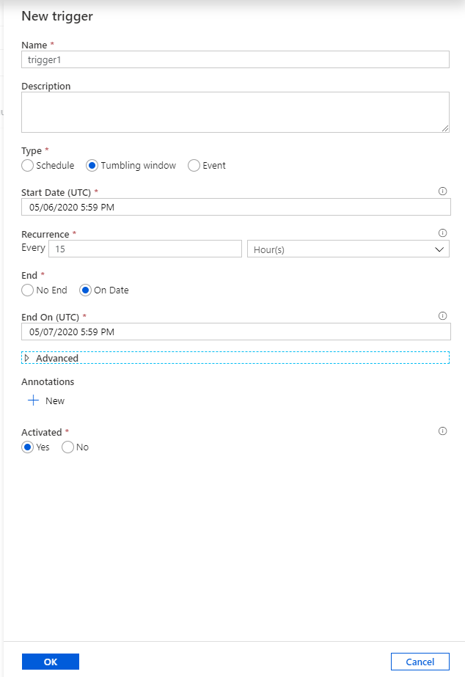

The following Advanced settings can be configured:

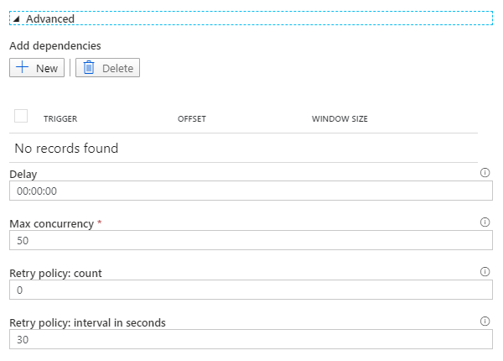

**Event Triggers:**

Event triggers can execute one or more pipelines when events happen. You use them when you need to execute a pipeline when something happens, instead of at specific times.

Event triggers currently only respond to blobs. That means that you can trigger a pipeline when you:

* Create a blob
* Delete a blob
* Create or delete a blob

Event triggers and pipelines have a many-to-many relationship. That means that one event trigger can execute many pipelines, and one pipeline can be executed by many event triggers.

Configure the details of the Blob related event that will causes the trigger to execute:

